**Installation of the System**

Installation process consists the following steps.

1. Web and database servers installation
2. Application installation
3. System configuration

**1. Web and Database Servers Installation**

XAMPP has been selected for installing the Apache, MySQL and PHP packages. XAMPP is bundled with Apache, MySQL, and PHP packages which are used to run the application.

**Install XAMPP in Windows**

1. Insert Patient Information Management System (PIMS) CD into the CD ROM.
2. Open the directory called “Install”.
3. Run the file “xampp-win32-1.7.3.exe” to install the web, database servers and the PHP .
4. Open the XAMPP control panel which is in the installed directory of the XAMPP. (i:e C:/ xampp / xampp-control)
5. If the Apache and MySQL servers are not started , click on the “Start” button to start those services . Following figures show the “Start” and “Stop” statuses of the Apache and MySQL servers.

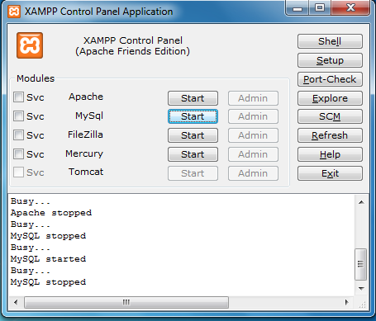

**Figure A.1** Apache and MySQL servers are not running.

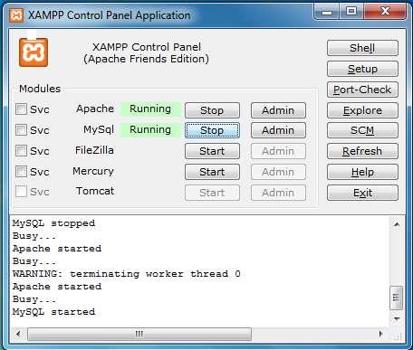

**Figure A.2** Apache and MySQL servers are running.

**Install LAMPP in Linux**

1. Insert Patient Information Management System (PIMS) CD into the CD ROM.
2. Open the “Install” directory and copy the xampp-linux-1.7.3a.tar to a location in the file system. (Note: Copying location should be have Read, Write, Executable permissions )
3. Extract the “xampp-linux-1.7.3a.tar”
4. The web directory “htdocs” is included in the /lampp directory.
5. Start the services by using the following command.

/opt/lampp/lampp start (Note: Here opt is the directory where lampp is located)

If the services got started , following messages are displayed

Starting XAMPP 1.7.3a...  
LAMPP: Starting Apache...  
LAMPP: Starting MySQL...  
LAMPP started.

Ready. Apache and MySQL are running.

**2. Application Instillation**

1. Open the directory called “System” which is in the CD.
2. Copy the pims.zip or pims.tar.gz file into the web directory of the XAMPP. The web directory “htdocs” is located in the /xampp/ directory. (Note: In Linux /lamp)
3. Extract the copied file.
4. If the application environment is Linux , necessary read write and executable permissions should be set to the application directory . For example,

chown –R apache.apache pims

chmod –R 755 pims

**3. System Configuration**

1. Log in to the MySQL server and create a database with the name “pims” .
2. Select the created database and import the dbscript.sql file which is in the “Data” directory of the CD.
3. Login to the system by using default admin account’s credentials.
4. Following figures explain the database system configuration process.